caAERS Phase II

Mayo Clinic Cancer Center Adoption Plan
(Task 5.1)

DOCUMENT REVISION HISTORY
Version Number | Date | Description
1.0 | 4/1/2008 | First Draft
1.1 | 4/7/2008 | Second Draft
1.2 | 4/9/2008 | Input from S Elcombe

Introduction

Project Overview
The goal of this adoption plan is to clearly articulate how the Mayo Clinic Cancer Center (MCCC) plans to implement caAERS as its adverse event management system. The adoption strategy includes plans for a pilot evaluation phase, development of an integration strategy, a data sharing strategy, and the development of an implementation plan.

Project Participants and responsibilities

The MCCC caAERS team consists of Mses. Sharon Elcombe, Sonja Hamilton, Jean Hanson, and Jennifer Frank. All participated in the caAERS adopter activities since its inception. Brad Andersen is new to the team and Michael Carston has been a participant for the past 6 months. The team will be responsible for installing, piloting, integrating/configuring caAERS at the MCCC, and training new users of the system.

Additionally, Robbin Peterson, a MCCC Clinical Research Associate (CRA), Patricia McNamara, the MCCC AE Coordinator and members of the Clinical Trials Management System (CTMS) IT staff, and others, as necessary, will participate in piloting, evaluating, and integration strategy development.

Mayo Clinic IT staff, including IT Security, will be responsible for approving and implementing necessary components for data sharing and ensuring that data sharing on the caGrid is handled appropriately.

Dependencies/Risks

The overall strategy is dependent upon:
- our ability to obtain and install the appropriate hardware in a timely manner,
- access to API documentation,
- access to data models.

Constraints / Issues
- Past and on-going MCCC clinical trials do not routinely collect hospitalization and expectedness on every AE. This will pose challenges for legacy data and on-going trials. The data capture cost of adding those fields to every study in the future will need to be assessed.
- The caAERS application does not contain a cycle or course number associated with routine adverse events. The MCCC data entry system relies on a cycle number to associate adverse events with the correct treatment cycle as we do not routinely collect start and stop dates for adverse events on phase II and III studies.
- The current MCCC CTMS will not allow for updates to adverse events via the caAERS mechanism and also via the data entry system. Therefore, we will only be able to instantiate caAERS for studies where MCCC is the data center and the only participant in the study.
- Only studies where the MCCC is the data center can be instantiated, as studies with other data centers will not be defined in the caAERS data base. This may change as the product is instantiated across the Cooperative Group system.
- Because MCCC does not currently have a Tomcat server available in the DMZ, we will not be able to use caAERS as the point of entry for studies that use our remote data capture system outside of our firewall e.g. NCCTG studies.
- MCCC will eventually have a potential for several hundred CRAs who would use the caAERS system, including personnel at other sites. At the current time, we do not have a mechanism to import personnel into the caAERS system. This will have to be addressed due to the time constraints on the personnel at MCCC who have responsibility for keeping personnel up to date in our database and our desire to not store data in two places and thus sync duplicate data.
- Data Sharing will be constrained by institutional and MCCC policy and the ability to implement those policies in the caGrid security environment.
- Data base rules and dependencies based on which database is used by the MCCC and where we install caAERS.

Project Plan
Pilot: The MCCC will pilot caAERS on two on-going studies where the MCCC is the data center. The pilot will assess both the AE data collection and AEs requiring AdEERS reporting. The studies and patients will be imported initially with subsequent patients and AEs added manually. Based upon the pilot outcome a decision will be made regarding how caAERS should be instantiated into the Mayo CTMS system.
Integration: The intention is that users will enter all AEs into caAERS. caAERS will pre-fill study and subject data directly from the MCCC CTMS via APIs. Those AEs requiring expedited reporting will be routed to AdEERS via caAERS. All AEs will be uploaded to the MCCC CTMS.
- Functional Tasks (see Appendix B)
- Identify protocols for parallel testing and determine which protocols can be integrated with the caAERS application on an ongoing basis.
- Define the process for adding personnel to caAERS
- Determine who will ensure that new protocols are loaded correctly to caAERS and add data that can not be imported from our CTMS
- Determine who will define local rules in caAERS
- Determine frequency of import of patients from the MCCC CTMS to caAERS
- Write SOPs and working instructions for the business processes
- Technical Tasks (see Appendix A)
- Determine with the developers if the APIs are bidirectional.
- Determine what data elements in our CTMS are necessary for caAERS interaction and what the data types are.
- Get data model from developers
- Describe in and out systems involved in integration of the two systems.
- Develop security model
- Install caAERS
- Set up user accounts
- Batch load protocols, patients and legacy adverse event data in caAERS
- Data Sharing: Based on lessons learned during the caAERS construction and transition phases, a data sharing plan will be developed that will consider institutional policies, technical infrastructure, and security.
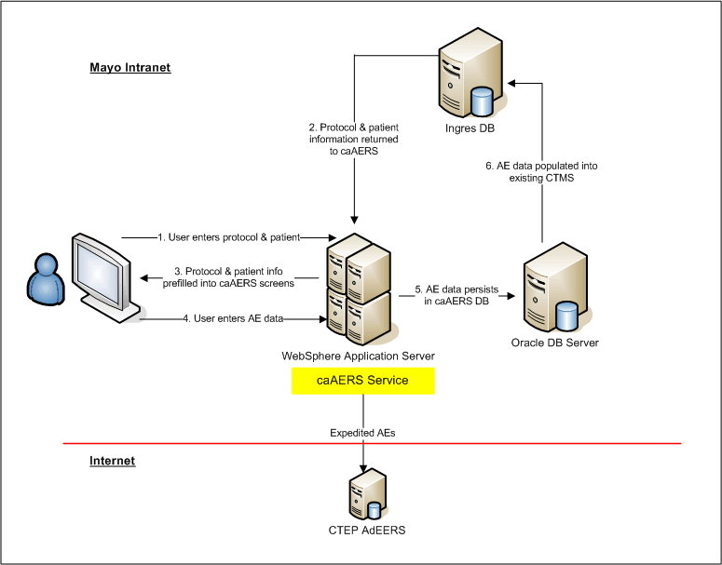

Appendix A
caAERS Technical Plan
Mayo Clinic Cancer Center
Task | Responsibility | Due Date | Status
Install caAERS | Brad |  | Completed
Set up user accounts | Brad |  | Completed
Get data model from developers | Brad | 4/11/08
Get APIs from developers | Brad | 4/11/08
Determine what data elements & types are necessary for caAERS | Brad, Michael, Randy S.
Determine in and out systems | Brad, Michael, Randy S.
Develop security model | Brad, Michael, Randy S.
Batch load protocol info for test studies in caAERS | Brad
Batch load patients on test studies in caAERS or connect via API | Brad
Batch load legacy AEs for test studies in caAERS or connect via API | Brad
Data Sharing plan | Sharon, Sonja, Brad, Michael

Appendix B
caAERS Business Plan
Mayo Clinic Cancer Center
Task | Responsibility | Due Date | Status
Write Adoption Plan | Sharon, Sonja | 5/7/08 ? | In process
Identify studies for testing | Jean, Robbin | 4/25/08
User Acceptance Testing | Jean, Robbin
Define process for adding personnel to caAERS on an on-going basis | Sharon, Sonja
Determine process for importing new protocols to caAERS | Sharon, Sonja
Determine QA process when new protocols added | Sharon, Sonja
Determine process for adding local rules to caAERS | Sharon, Sonja
Determine process for import of new patients on test studies to caAERS | Sharon, Sonja
Write local SOPs and Working Instructions | Sharon, Sonja, Jean, Robbin, Jennifer ??
Training | Jean, Robbin, Jennifer

